Technology Stack [Architecture & Stack]

|  |  |
| --- | --- |
| Date | 25 November 2022 |
| **Team ID** | PNT2022TMID51361 |
| Project Name | **Exploratory Analysis of RainFall Data in India for Agriculture** |
| Maximum Marks | 4 Marks |

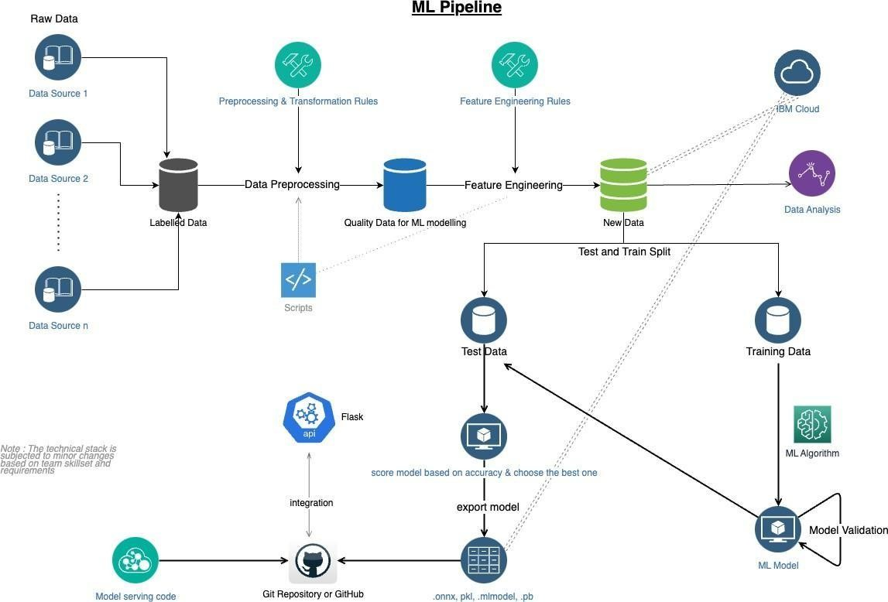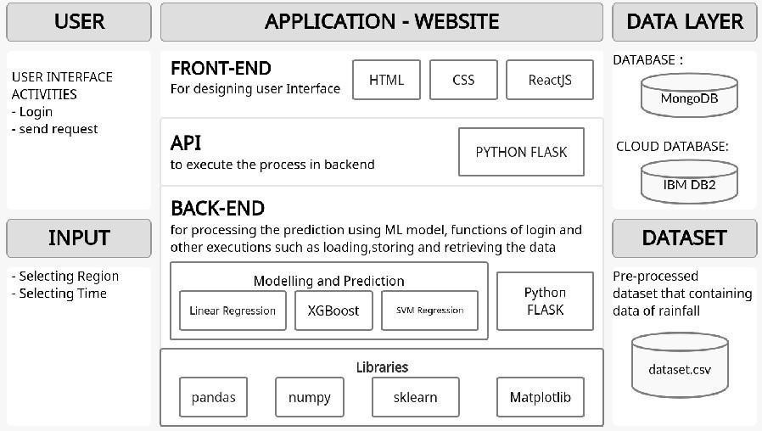

Technical

Architecture:

Design Phase - II 1

**Table-1: Components & Technologies**

|  |  |  |  |
| --- | --- | --- | --- |
| **S.No** | **Component** | **Description** | **Technology** |
| 1. | User Interface | How user interacts with application e.g., Web UI, Mobile App. | HTML, CSS, JavaScript, Bootstrap, React JS |
| 2. | Database | The place where data can be stored and retrieved during the execution of the application | CSV Store, NoSQL |
| 3. | Cloud database | Used for integrating components while using python flask | IBM DB2, IBM Cloudant |
| 4. | API | Used to call the functions in order to access the execution in another framework | Python Flask , NodeJS (if needed) |
| 5. | Application Logics | Logic for each and every process in the application | Python, JavaScript |
| 6. | Machine Learning Model | The model is developed to predict the rainfall using ML algorithms | Sklearn Regressors, ML Algorithms, XGBoost |
| 7. | Data Pre-processing and Analysis | The available data is formatted or converted into the format which will be suitable for the ML model | Numpy, Matplotlib, Pandas, Seaborn, Geopandas |

**Table-2: Application Characteristics**

|  |  |  |  |
| --- | --- | --- | --- |
| **S.No** | **Characteristics** | **Description** | **Technology** |
| 1. | Open-Source Frameworks | Backend Framework, Non-structured Database, CSS Framework styling | Python Flask / NodeJS, MongoDB, IBM DB2, CSS-3 |
| 2. | Security Implementations | Email Verification and authentication, Authentication and authorisation using JSON object by comparing the data exists in database | SSL Certs, Direct verification using Backend  Framework |
| 3. | Scalable Architecture | To ensure that enough resource is allocated on the hosting platform to keep up with demand | IBM Cloud Kubernetes Service |
| 4. | Availability | The website will be made available by hosting it in cloud hosting platforms | Heroku cloud hosting (for testing) , IBM cloud hosting |
| 5. | Performance | Multiple prediction requests should be handled  simultaneously without affecting the speed and accuracy of prediction | Load Balancers and Distributed servers |

Design Phase - II 2